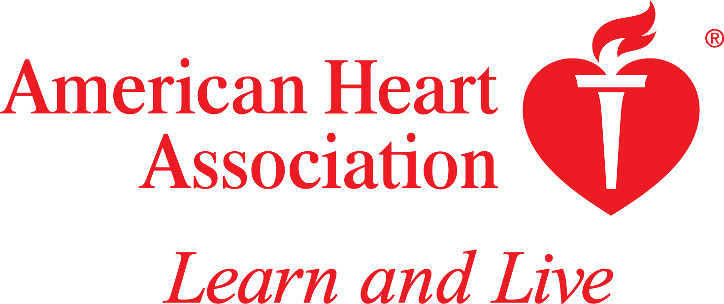
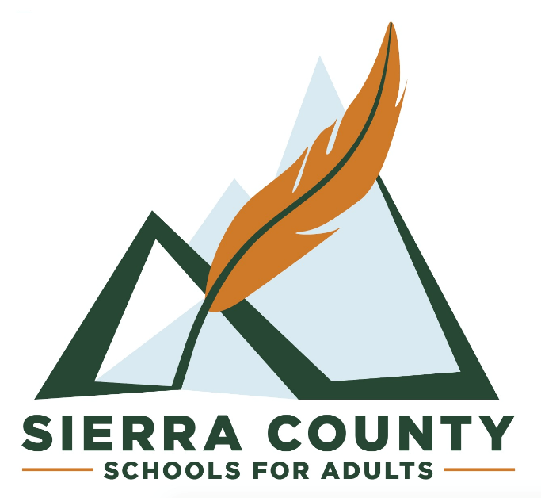

Heartsaver CPR/AED/First Aid June 1st 10AM-3PM $85.00

This class is for all community members 15+, 5 hour class teaches
on adult,child and infant CPR/AED & First Aid….includes and AHA CARD

Friends and Family CPR June 8th 10AM-1PM $40.00

This class is for kids 6th Grade +, teaches basic Cardiac Arrest recognition,
calling 911, CPR & choking. Includes a certificate of completion from SCSA.
2 Cert

Heartsaver Pediatric June 22nd, 10am-2PM $85.00
This class is for all community members 12+,
teaches on child and infant CPR/AED & First Aid, Includes and AHA Card.

